**Emotion Detection using Convolutional Neural Network / Deep learning**

**Members:**

Nguyễn Tuấn Dũng - 20205148 - dung.nt205148@sis.hust.edu.vn

Hoàng Đức Trung - 20200640 - trung.hd200640@sis.hust.edu.vn

Đoàn Tuấn Hùng - 20205154 - hung.dt205154@sis.hust.edu.vn

1. **Introduction**

As humans, we learn to express ourselves and understand others’ feelings. Over time, the process of recognizing each other’s emotions becomes our nature. Yet, having a machine figuring out human sentiments can be challenging: it is virtually impossible to write a program that can tell human emotion apart. There are billions of people on the planet and each of them carries different characteristics and features…

This is where deep learning comes into play.

Deep learning is a subfield of machine learning that utilizes artificial neural networks and representational learning to teach computers to do what comes natural to humans. If computers are provided with sufficient and accurate data and are trained using appropriate algorithms, they can actually perform what we think are only feasible to us.

In this project, our aim is to build a deep learning model that can categorize and detect 7 basic human emotions: happiness, sadness, disgust, fear, surprise, anger and neutrality.

1. **Project details**
2. ***Dataset.***

The dataset used for this project is Fer2013 from kaggle.com, which contains approximately 30,000 images of human portraits with different emotions in a 48x48 grayscale format.

1. ***Technologies.***

The language of choice for the project is Python, along with Tensorflow / Keras machine learning framework. We also use tkinter to build a graphical interface to demonstrate the model.

1. ***Algorithms***

We will build a deep learning model using convolutional neural networks, which is mostly used for image recognition and processing. The model will be passed through a number of layers in the network before it produces an output.

The first several layers will be the convolutional layers, where the input image is passed through a number of filters to reveal the needed attributes to produce accurate results.

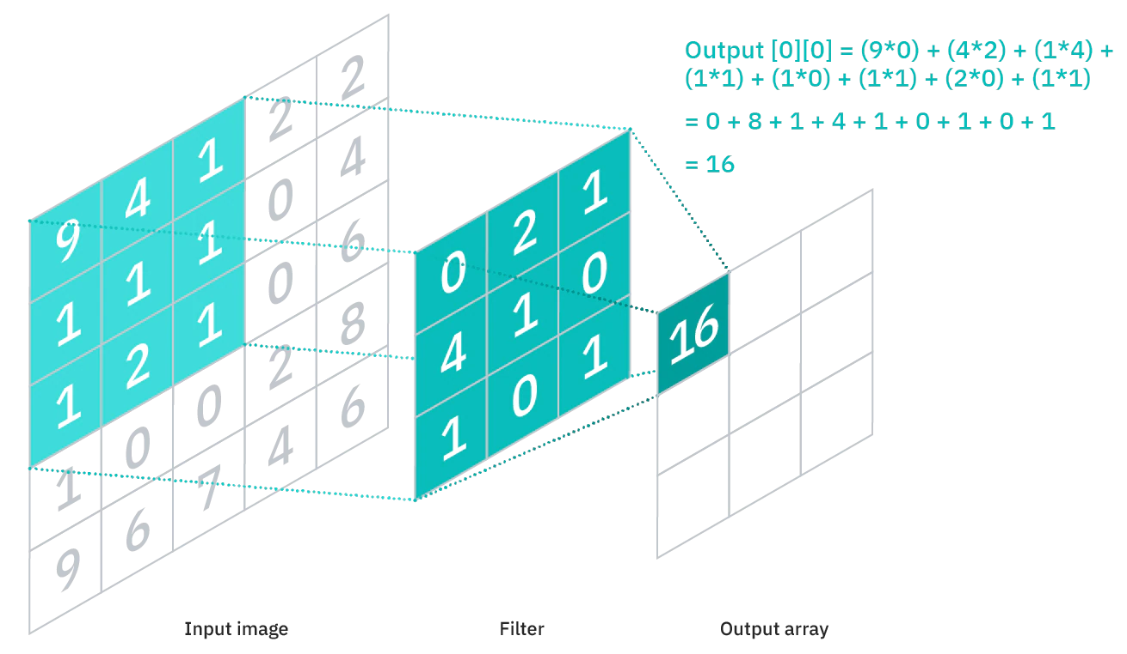

Each convolutional layer will be followed by a max pool layer, which downsamples the image to produce a downsampled feature map. The downsampled version of the image will help mitigate the computational costs but still contain the sharp and smooth features of it.

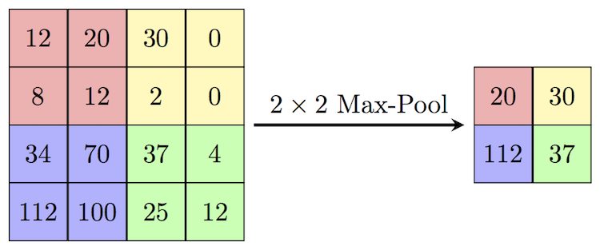

Next comes the fully-connected layers, consisting of the weights and biases along with the neurons and is used to connect the neurons between two different layers. These layers are usually placed before the output layer and form the last few layers of a CNN Architecture.

Within each layer, an activation function will be called. The activation functions can help approximate any kind of continuous or complex relationship between variables of the network and help us simplify the output. Our model will be utilizing ReLU and softmax activation functions.

The output of the network will be a vector containing values between 0 and 1, which correspond to the probabilities of each category. In our case, they are the probabilities of the emotions in the input image.

**3. Model application**

Facial emotion detection systems can be used by bots to improve human interaction and provide suitable help to users. They can also help children with autism, people with blindness, monitor attention signs for driver safety, and more.